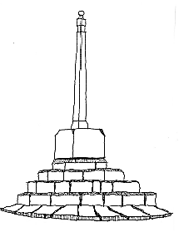
Orchard House
Congresbury Parish Council
The Old School Rooms
Station Road
Congresbury
BS49 5DX

Tel: 01934 838802

Chairman: Jane Clarke www.congresbury-pc.gov.uk
Parish Clerk: Nicky Andrews Email: clerk@congresbury-pc.gov.uk
RFO: Gemma Palmer Email: finance@congresbury-pc.gov.uk
Administrator: Catrin Lewis Email: admin@congresbury-pc.gov.uk

Congresbury Parish Council
Meeting Schedule 2024/2025

Month | Full Parish  Council | Finance Committee | Staffing Committee | Planning Committee
May | 13th May |  |  | 20th May
June | 10th June |  |  | 24th June
July | 15TH July |  |  | 29th July
August | 12th August | 5th August TBC |  | 19th August
September | 16th September |  |  | 30th September
October | 14th October |  |  | 28th October
November | 11th November |  |  | 25th November
December | 9th December | 2nd December TBC |  | 16th December
January 2025 | 13th January |  |  | 27th January
February | 10th February | 3rd February TBC |  | 24th February
March | 17th March |  |  | 31st March
April | 14th April |  |  | 28th April

Notes:

- Additional meetings may be called in the event of urgent business arising.
- Scheduled meetings may be cancelled if there is no business arising.

