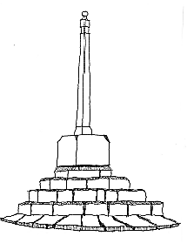
Orchard House
Congresbury Parish Council
The Old School Rooms
Station Road
Congresbury
BS49 5DX

Tel: 01934 838802

Chairman: Jane Clarke www.congresbury-pc.gov.uk
Parish Clerk: Nicky Andrews Email: clerk@congresbury-pc.gov.uk
RFO: Gemma Palmer Email: finance@congresbury-pc.gov.uk
Administrator: Catrin Lewis Email: admin@congresbury-pc.gov.uk

Congresbury Parish Council
Meeting Schedule 2025/2026

Month | Full Parish  Council | Finance Committee | Staffing Committee | Planning Committee
May | 12th May |  |  | 19th May
June | 16th June |  |  | 30th June
July | 14th July |  |  | 28th July
August | 11th August | 4th August TBC |  | 18th August
September | 15th September |  |  | 29th September
October | 13th October |  |  | 27th October
November | 10th November |  |  | 24th November
December | 8th December | 1st December TBC |  | 15th December
January 2026 | 12th January |  |  | 26th January
February | 9th February | 2nd February TBC |  | 23rd February
March | 16th March |  |  | 30th March
April | 13th April |  |  | 27th April

Notes:

- Additional meetings may be called in the event of urgent business arising.
- Scheduled meetings may be cancelled if there is no business arising.

